Apple Inc. (AAPL) Stock Analysis

Dataset Overview
This report analyses five years of historical daily trading data for Apple Inc. (AAPL), obtained from Yahoo Finance using the yfinance API in Python. The dataset includes the Open, High, Low, Close, Adjusted Close, and Volume for each trading day. Before beginning the analysis, the data was checked for missing values and duplicate records. No issues were found, indicating that the dataset was clean, complete, and ready for analysis without any additional preprocessing.

Data Transformation Techniques Applied
To prepare the data for analysis, the Year and Month were extracted from the Date column to make it easier to group and compare stock performance over different time periods. Two new features were also created: Daily Range, which measures the difference between the day's highest and lowest prices, and Daily Change, which shows the difference between the opening and closing prices. These features provided a clearer picture of daily price movements.
The dataset was then filtered to identify trading sessions with above-average closing prices, above-average trading volumes, and below-average opening prices. These filtered datasets were merged to highlight days where these conditions occurred together, such as sessions with both high closing prices and high trading volumes. Finally, the data was grouped by year to calculate summary statistics, including the average closing price, total trading volume, and annual high and low prices. The Date column was then set as the index, making it easier to perform rolling averages, resampling, and other time-series analyses.

Trends Identified
Over the five-year period, Apple's stock showed a clear long term upward trend, with the average closing price increasing from year to year. However, this growth was not consistent, as the stock experienced regular short-term gains and losses. The daily percentage change and rolling volatility analyses showed that periods of high price fluctuations were often followed by more stable trading periods. In addition, comparing monthly average closing prices across different years revealed that some months consistently performed better than others, suggesting recurring seasonal trends in the stock's performance.
The filtering analysis also revealed some interesting patterns. A total of 516 trading days closed above the overall average closing price of approximately $197.21, while 492 days recorded trading volumes above the average of around 64.91 million shares. In comparison, 738 days opened below the average opening price. When these conditions were combined, only 86 trading days had both an above average closing price and above-average trading volume. However, 409 trading days had both a below-average opening price and above-average trading volume. This suggests that lower opening prices were often accompanied by increased trading activity.
Features Created
- Daily Price Change and Percentage Change – Created to measure both the actual price difference and the percentage change between the opening and closing prices for each trading day, providing a clearer view of daily stock performance.
- Weekday – Extracted from the Date column to examine whether stock performance and trading activity varied across different days of the week.
- 7-Day and 30-Day Moving Averages – Calculated to smooth out short-term price fluctuations and highlight the underlying trend in Apple's closing price over time.
- Monthly Returns – Computed to evaluate month-to-month stock performance, including a comparison of the first six months across all five years to identify recurring performance patterns.
- 7-Day and 30-Day Volatility – Calculated using the rolling standard deviation of the closing price to measure how much the stock price fluctuated over both short-term and longer-term periods, providing insight into changes in market volatility and risk.

Visualizations
1. AAPL Closing Price Trend (5 Years)
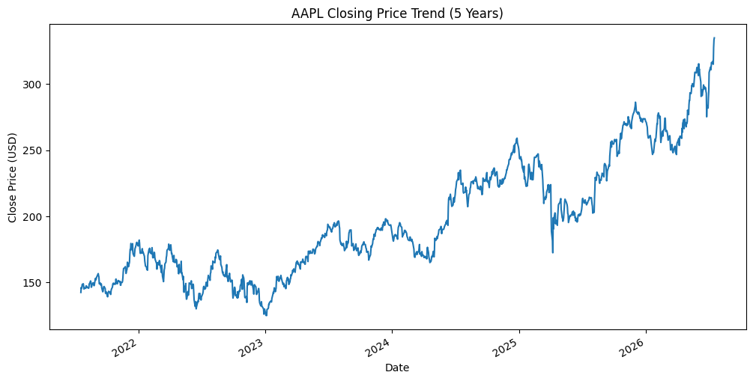
Fig [1] Daily closing price across the full five-year period, illustrating the sustained upward trajectory.
2. AAPL Monthly Average Closing Price
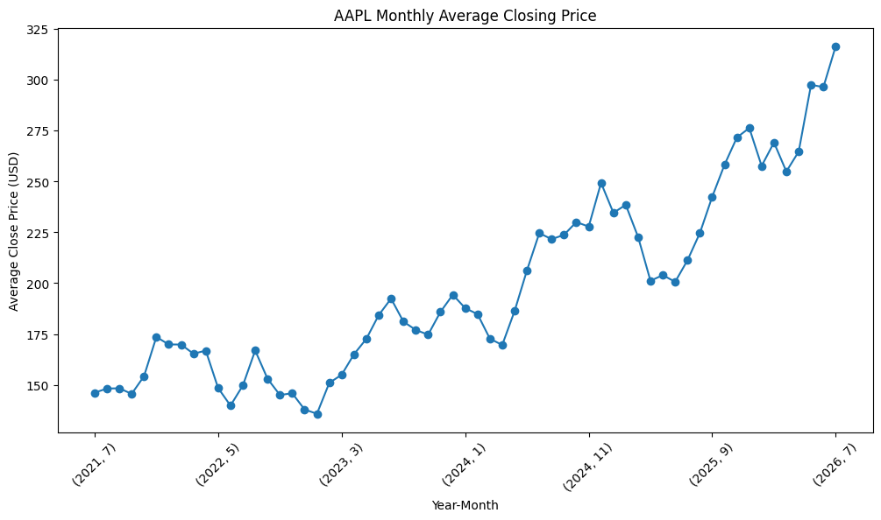
Fig [2] Average closing price by year and month
3. AAPL Closing Price with 7-Day and 30-Day Moving Averages
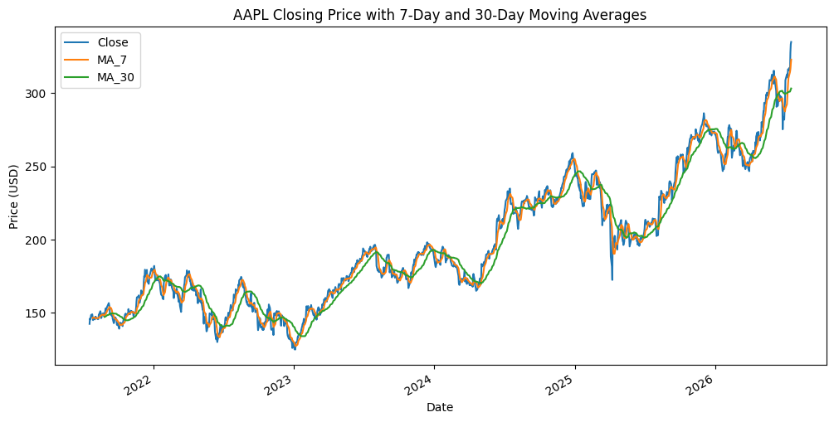
Fig [3] Closing price with 7-day and 30-day moving averages, showing short-term price fluctuations alongside the long-term market trend.

4. AAPL Monthly Average Closing Price by Year
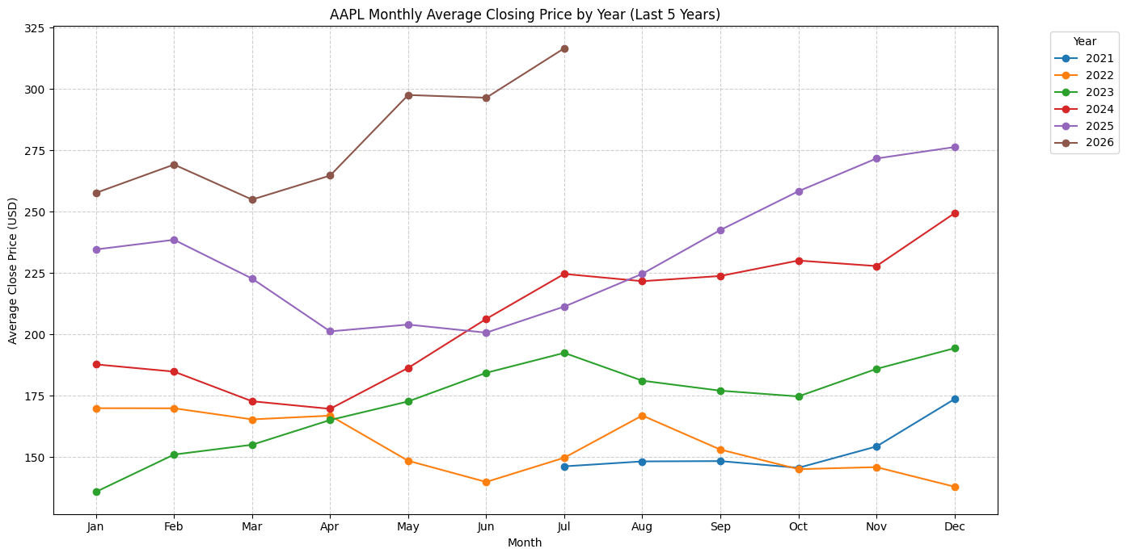
Fig [4] Monthly average closing prices for each year, allowing direct comparison of seasonal trends and stock performance across the five-year period.

5. AAPL Daily Percentage Change
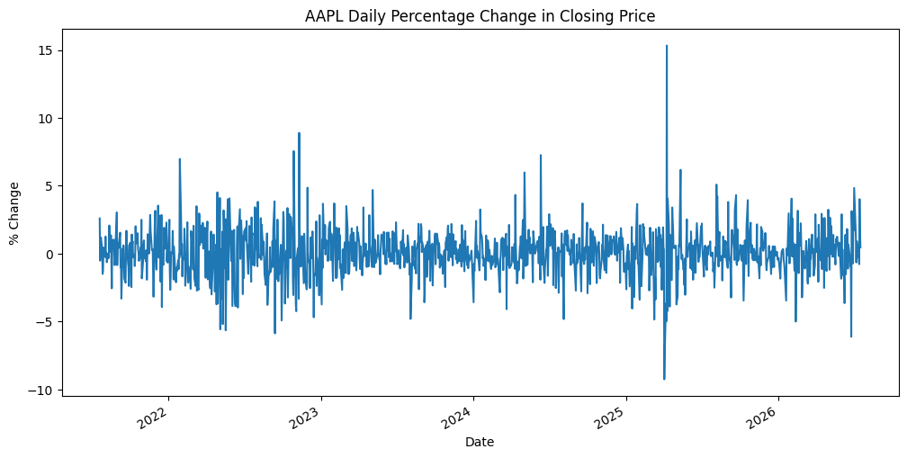
Fig [5] Day to day percentage change in Apple’s closing price, highlighting periods of increased market volatility and significant price fluctuations.

6. AAPL Monthly Returns for the First Six Months, by Year
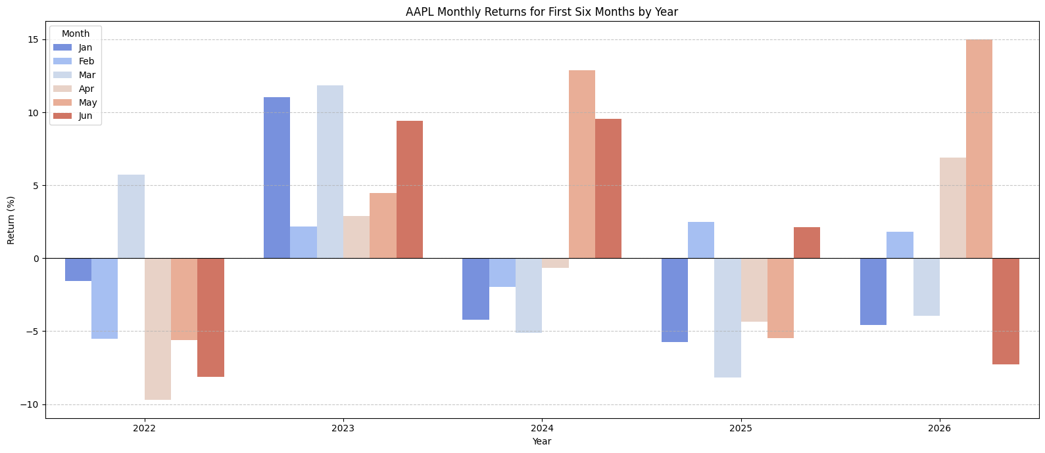
Fig [6]. Monthly returns for the first six months of each year, enabling direct comparison of early year stock performance and identifying periods of consistently strong or weak returns across the five-year period.

Key Insights
- Apple's stock price followed a clear upward trend over the five-year period, although the growth was not consistent and was accompanied by regular periods of market volatility.
- The 7-day and 30-day moving averages highlighted different aspects of price behaviour, with the shorter moving average capturing daily market movements and the longer moving average revealing the underlying upward trend by smoothing out short-term volatility.
- Daily percentage change and rolling volatility analyses showed that periods of heightened price fluctuations alternated with more stable trading periods, demonstrating that market volatility varied over time rather than remaining constant.
- Trading volume analysis showed that sessions with below-average opening prices were more frequently associated with above-average trading volumes than sessions with both above-average closing prices and trading volumes, suggesting increased investor activity during price declines.
- Monthly returns fluctuated between positive and negative values throughout the five years, demonstrating that despite Apple's strong long-term growth, short-term performance remained influenced by normal market fluctuations.
- Filtering analysis revealed that trading volume was more often elevated on days with below average opening prices (409 days) than on days with above average closing prices (86 days), indicating greater market activity during price declines.

Recommendations
- Future analysis could combine moving averages with trading volume to identify potential buying opportunities during price declines while using the 30-day moving average to confirm the overall market trend.
- Expanding the dataset beyond the five-year period or comparing Apple with other technology stocks could help determine whether the observed patterns are consistent across different market conditions.

